Infrastructure under Livestock Farm Complex (LFC)
Sl. No. | Name of the unit | Capacity of the unit | Breeds/species /strains maintained | Platform 1 | Platform 2 | Platform 3
1 | Dairy Cattle Unit | 20 Cows | i. Sahiwal cattle  ii. Holstein Friesian crossbred cattle | 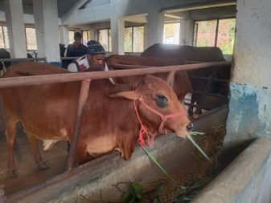 | 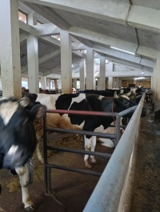 | 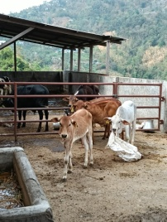
2 | Pig Unit | 40 Sows + 6 Boars | Large White Yorkshire | 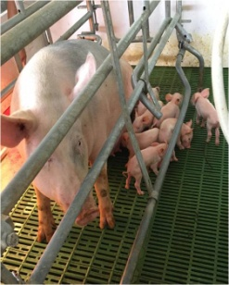 | 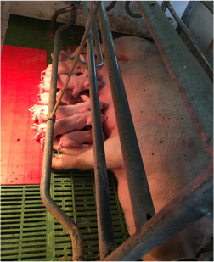 | 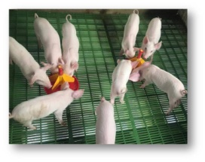
3 | Duck Unit | 100 Ducks | i. White Pekin  ii. Khaki Campbell | 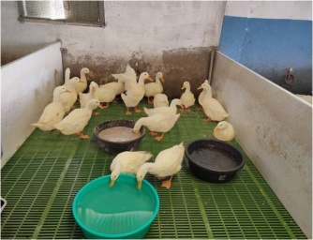 | 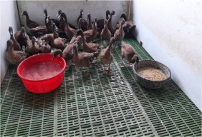 | 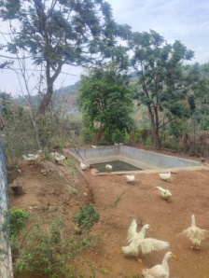
4 | Goat Unit | 40 Doe +10 Buck | i. Assam Hill Goat  ii. Beetal x Local Cross | 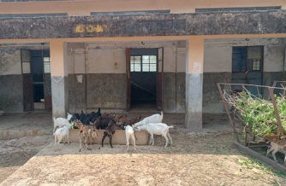 | 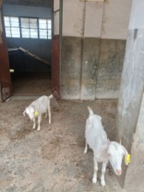 | 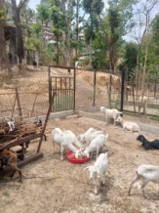
5 | Poultry Unit | 500 Broilers  500 Layers  - Quails | i. White Leghorn  ii. Guinea fowl  iii. Japanese Quail  iv. Sikhar (Local chicken)  v. BV – 380 (Brown commercial layer) | 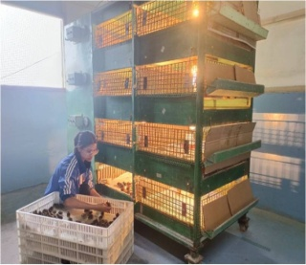 | 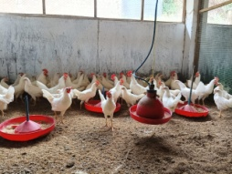 | 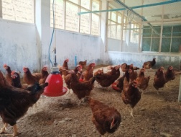
6 | Hatchery Unit | 10000 egg capacity Hatchery Unit | - | 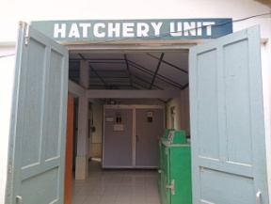 | 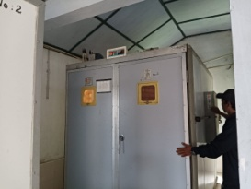 | 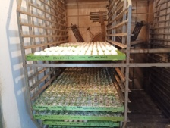
7 | Fodder Unit | 3 Hectare of Fodder land | i. Congo-signal Grass  ii. Hybrid Napier Grass  iii. Banana Plants  iv. Jack fruit trees  v. Rubber trees | 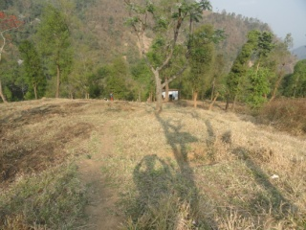 | 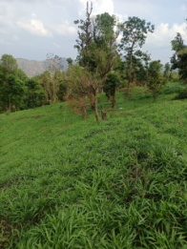 | 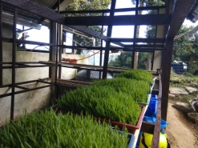

Staff Details:
- Farm Assistant: 04
- FCLA: 01
- MTS: 03
- Contractual Workers: 08

